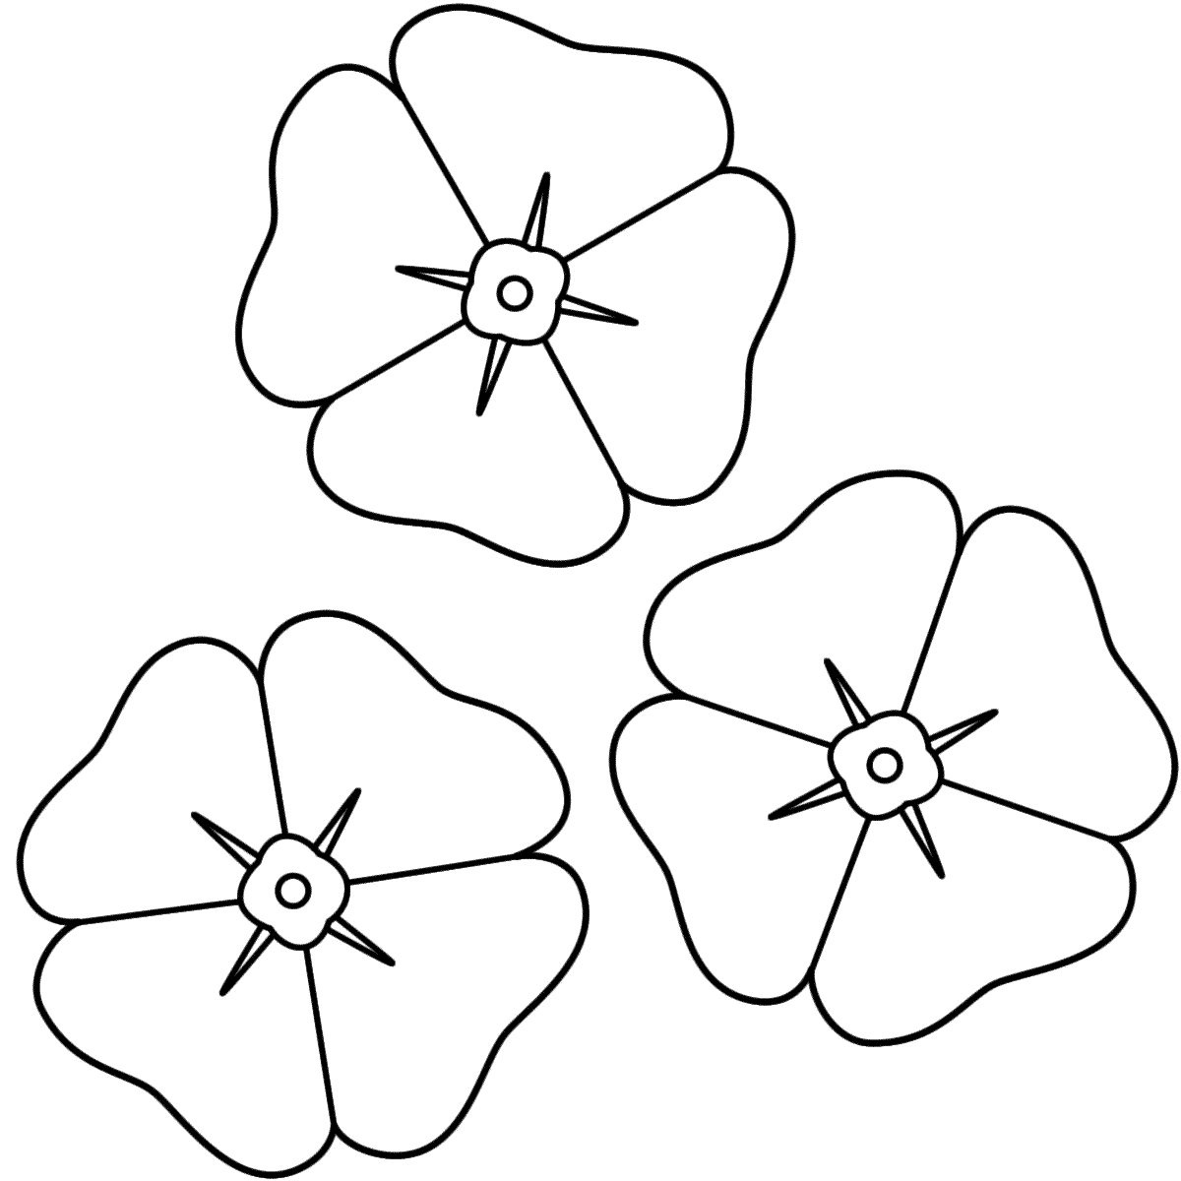

Instructions:
- Color petals Red
- Color center Black
- Cut out Flowers
- Write a message to our Veterans

